SCH4U September 2017
All Organic Compounds Nomenclature
- Name the following compounds using IUPAC rules.
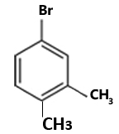  - _______________________________________ | 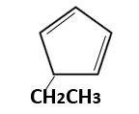  - ________________________________
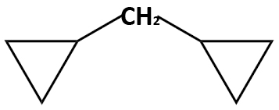  - ______________________________________ | 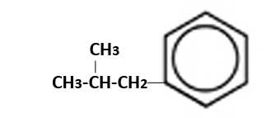  - ________________________________
CH₃-CH₂-O-CH₂-CH₂-CH₃  - _____________________________________ | 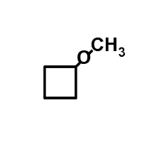  - _______________________________
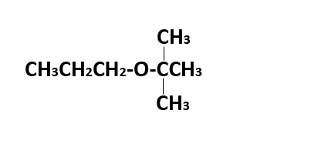  - ____________________________________ | 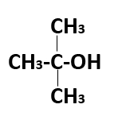  - ______________________________
HO – CH₂-CH₂-OH  - ____________________________________ | 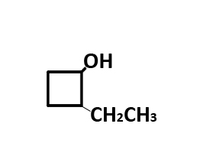  - ________________________________
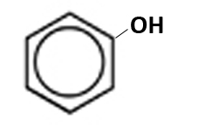  - ___________________________________ | 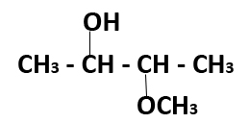  - _______________________________
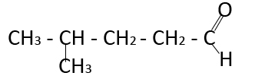  - __________________________________ | 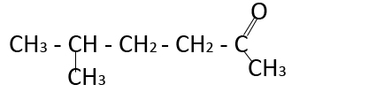  - _____________________________
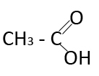  - ____________________________________ | 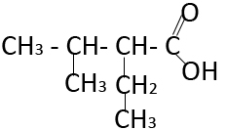  - _______________________________
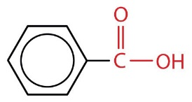  - ____________________________________ | 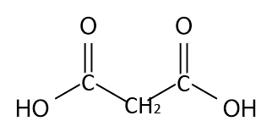  - ______________________________
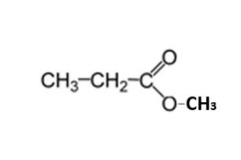  - ___________________________________ | 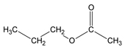  - ____________________________

- Draw the condensed structural diagrams for:
- 3,3-dimethyl-1-butyne | - 1,3-pentandione
- 4-bromo-1-cyclohexene | - 2-ethoxy-3-methylbutane
- 2,2-butandiol | - Phenol
- Hexanal | - 5-ethyl-4-methyl-3-octanone
- 2-methoxybutanal | - 2,3-dimethylpentanoic acid
- Methylmethanoate | - Ethyl -2-methylbutanoate

