SCH4U March 2016
Organic Chemistry Review

Modified True/False
Indicate whether the sentence or statement is true or false. If false, change the identified word or phrase to make the sentence or statement true.

____ 1. Butenoic acid contains a carbon-carbon double bond and a carboxyl group. _________________________

____ 2. Formic acid is the common name of ethanoic acid. _________________________

____ 3. Carbon-carbon double and triple bonds are more reactive than carbon-carbon single bonds. _________________________

____ xx4. A polar molecule has low Van der Waal forces and a low boiling point. _________________________

____ xx5. CH₄ has a higher melting point than CH₃OH. _________________________

____ 6. The correct IUPAC name for the structure below is 2,5,6-trimethyldecane. _________________________

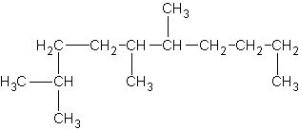

____ 7. The following structure can be named 2-phenylpropane or isopropylbenzyne. _________________________

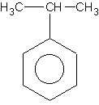

____ 8. Alkanes are highly reactive and combustive. _________________________

____ 9. The correct IUPAC name for the structure below is 2,4-dichlorobutane. _________________________

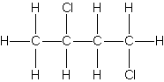

____ xx10. Pentane has a higher boiling point than 2-chloropentane. _________________________

____ xx11. Glycerol is found in many moisturizers because it forms hydrogen bonds with water. _________________________

____ xx12.
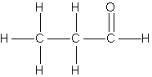
will have a higher boiling point than
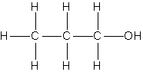. _________________________

____ 13. When alcohols are oxidized, carbon dioxide, aldehydes, ketones and water may be produced. _________________________

____ 14. Carboxylic acids are strong acids found in many sour and tangy foods. _________________________

____ xx15. Ethanoic acid is soluble in water, but hexanoic acid is not. _________________________

____ xx16. C₂H₅NH₂ has a higher boiling point than C₂H₅OH. _________________________

____ xx17. Ethanamide has higher melting point than N,N-diethylbutanamide. _________________________

____ 18. Butenoic acid and ethanol can be used to produce ethylbutanoate. _________________________

Multiple Choice
Identify the letter of the choice that best completes the statement or answers the question.

____ xx19. An amine is characterized by what functional group?
a. | -CO2CH3 | d. | -CHO
b. | -NH2 | e. | -OH
c. | -CO2H

____ 20. Which of the following is an alcohol?
a. | NaOH | d.
b. |  | e. | 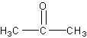
c. | 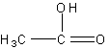

____ 21. When two alcohols undergo a self condensation, what is formed?
a. | liquid alcohol | d. | an aldehyde
b. | a ketone | e. | an ether
c. | an ester

____ 22. How many actual double bonds does the benzene ring possess?
a. | 4 | d. | 1
b. | 3 | e. | 0
c. | 2

____ 23.
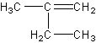
The correct name for the compound given above is which of the following?
a. | 2-methyl-1-butene | d. | 3-methyl-2-butene
b. | pentene | e. | 2-ethyl-1-pentene
c. | 2-ethyl-1-propene

____ 24.
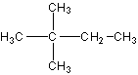
What is the correct name for the above compound?
a. | 2,3-dimethylbutane | d. | 2,2-dimethylbutane
b. | hexane | e. | isohexane
c. | 2-methylpentane

____ 25.
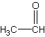
The compound above is classified as a(n)
a. | alkane | d. | ketone
b. | carboxylic acid | e. | alkene
c. | aldehyde

____ 26. Which of the following is a secondary alcohol?
a. | 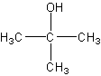 | d. | CH3OH
b. |  | e. | CH3CH2OH
c. | 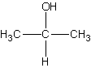

____ 27.
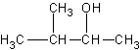
What is the correct name for the above compound?
a. | 2-methyl-3-butanol | d. | 3-methyl-2-butanol
b. | 2-pentanol | e. | none of these
c. | isobutanol

____ 28. What results when a secondary alcohol is oxidized?
a. | a ketone | d. | an acid
b. | an amine | e. | no reaction
c. | an aldehyde

____ xx29. Which statement is incorrect concerning these two molecules with the same formula, C₂H₆O?
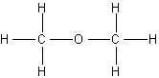 | 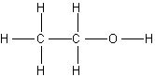
I. | II.

a. | compound (II) will more likely be soluble in water than compound (I)
b. | compound (I) will have a lower boiling point than compound (II)
c. | hydrogen bonding will be the most likely for compound (II)
d. | the vapour pressure of compound (II) will be lower than that of compound (I) at a given temperature
e. | compound (I) would be a better solvent

____ 30. The general formula for a cycloalkane can be represented by which of the following?
a. | CnHn | c. | CnH2n
b. | CnH2n+2 | d. | CnH2n-2

____ 31.
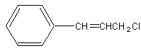
The correct name for compound above is which of the following?
a. | chloropropylbenzene | c. | 1-chloro-3-phenyl-3-propene
b. | 3-phenyl-1-choloropropyne | d. | 3-chloro-1-phenyl-1-propene

____ xx32.
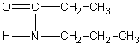

The correct name for the compound given above is which of the following?
a. | 3-amino-3-hexanone | c. | N-propylpropanamide
b. | ethyl ethanamide | d. | N-ethylethanamide

____ 33.
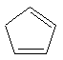
The correct name for the compound given above is which of the following?
a. | 1,3-cyclopentadiene | c. | 1,4-cyclopentene
b. | 1,4-cyclopentadiene | d. | 1,3-cyclopentene

____ xx34.
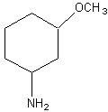
The correct name for the compound given above is which of the following?
a. | 1-amino-3-ethoxyhexane | c. | 1-amino-3-methoxycyclohexane
b. | 1-methoxy-3-amidecyclohexane | d. | 1-amino-3-methoxyhexane

____ 35.
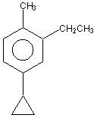
The correct name for the compound given above is which of the following?
a. | 1-propyl-3-ethyl-4-methylbenzene
b. | 4-cyclopropyl-2-ethyl-1-methylbenzene
c. | p,σ - methyl, ethylcyclopropylbenzene
d. | 1-propyl-3-ethyl-4-methylcyclohexane

____ 36. The correct structure for 1,4-dicyclopropylcyclohexane is which of the following?
a. | 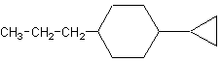
b. | 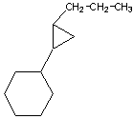
c. | 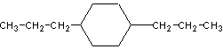
d. | 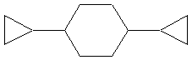

____ xx37. The correct structure for 1-methyl-2,4,6-trinitrobenzene(TNT) is which of the following?
a. | 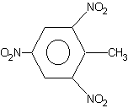 | c. | 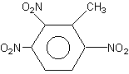
b. | 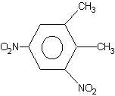 | d. | 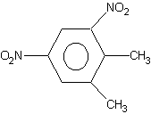

____ 38.
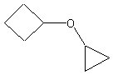
The correct name for the compound given above is which of the following?
a. | 2-cycloproproxylcyclobutane | c. | 2-cyclobutoxycyclopropane
b. | cyclobutylpropoxy ether | d. | cyclopropoxycyclobutane

____ 39. Of the five names listed below, four contain deliberate errors. Which is the only name is correct?
a. | 2-pentanal | d. | 1,2-dimethylpropanoate
b. | 2,3-dichloropentane | e. | n-methylpropanamide
c. | 3-methylpropanoic acid

____ 40. The reaction of CH₃CH=CH-CH=CH₂ with excess bromine gives chiefly
a. | 1,2-dibromo-3-pentene
b. | 3,4-dibromo-1-pentene
c. | 1,4-dibromo-2-pentene
d. | a mixture of the above three compounds
e. | none of the above three compounds

____ 41. The number of isomers of chlorodibromobenzene is which of the following?
a. | three | d. | six
b. | four | e. | seven
c. | five

____ 42. The formula for methyl ethanoate is which of the following?
a. | 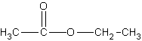 | c. | 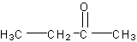
b. | 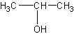 | d. | 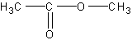

____ 43. The condensed formula of 2,3,4-trimethylpentane is which of the following?
a. | 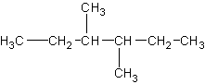 | c. | 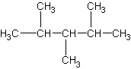
b. | 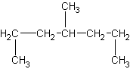 | d. | 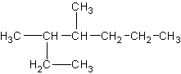

____ xx44.
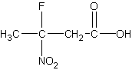
The correct IUPAC name for above compound is which of the following?
a. | fluorobutanoic acid | c. | 2-fluoro-2-nitrobutanoic acid
b. | 3-fluoro-3-nitrobutanoic acid | d. | 3-fluoro-2-nitropropanoic acid

____ 45.
The correct IUPAC name of the above structure is which of the following?
a. | 1-bromo-2-butene | c. | 4-bromo-2-butyne
b. | 1-bromo-2-butyne | d. | 4-bromo-1-methyl-1-propyne

____ 46. Which of the following compounds contains 10 carbon atoms?
a. | 2,2,3-trimethylheptane | c. | 2-methyldecane
b. | octane | d. | 2,3-dimethylheptane

____ xx47. 1-amino-4,4-difluoro-2-pentanol is the correct name for which of the following compounds?
a. | 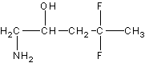 | c. | 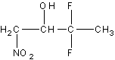
b. | 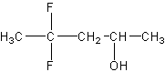 | d. | 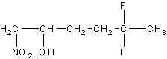

____ 48. 2-methyl-4-ethyl-3,3-dicyclopropyl-1-hexene is the correct name for which of the following?
a. | 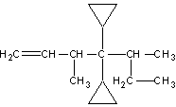 | c. | 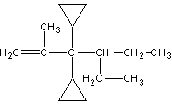
b. | 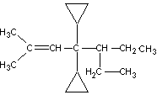 | d. | 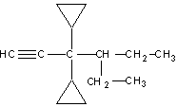

____ 49.
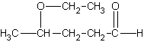
The correct IUPAC name for the compound above is which of the following?
a. | 5-ol-2-ethylpentane ether | c. | 3-propoxypentanal
b. | 2-ethoxy-5-pentanone | d. | 4-ethoxypentanal

____ 50. Which of the following is the correct name for the compound below?
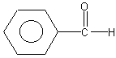
a. | benzene-ethanol | c. | methylbenzenal
b. | phenylmethanoate` | d. | phenylmethanol

____ 51. Which of the following is the correct name for the structure below?

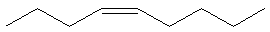
a. | trans-4-nonyne | c. | trans-4-nonene
b. | cis-5-nonene | d. | cis-4-nonene

____ 52. Which of the following is the correct name for the diagram below?
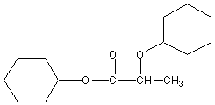
a. | propylcyclohexylcyclohexanoate | c. | dicyclohexanylpropanoate
b. | 2-cyclohexoxycyclohexylpropanoate | d. | methylcycloxypropanoate

____ 53. Which of the following is the correct IUPAC name for the compound below?
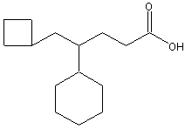
a. | 4-phenyl-6-cyclobutylhexanoic acid
b. | 3-phenyl-6-cyclobutylhexanoic acid
c. | 3-cyclohexyl-6-cyclobutylhexanoic acid
d. | 4-cyclohexyl-5-cyclobutylpentanoic acid

____ 54. Which of the following classes of organic compounds does not contain oxygen?
a. | aldehydes | d. | ethers
b. | amines | e. | amides
c. | amino acids

____ 55. The primary product of the following reaction is which of the following?
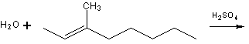

a. | 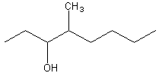 | c. | 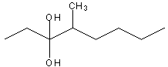
b. | 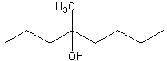 | d. | 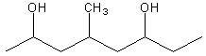

____ 56. When excess hydrogen bromide is added to pentyne, the possible product is which of the following?
a. | 1,1-dibromopentane | c. | 1,1,2,2-tetrabromopentane
b. | 1,2-dibromopentane | d. | 2,2-dibromopentane

____ 57. The primary product of the reaction below which uses excess HBr is which of the following?
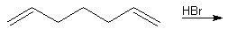

a. |  | c. | 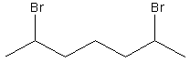
b. | 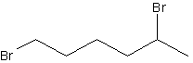 | d. | 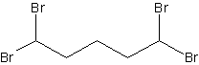

____ 58. The correct IUPAC name for the compound below is which of the following?
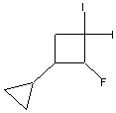
a. | 1,1-diiodo-2-fluoro-3-cycloproplycyclobutane
b. | 1-cyclopropyl-2-fluoro-3,3-diiodocyclobutane
c. | 1,1-diiodo-3-cyclopropyl-4-fluorocyclobutane
d. | 1-fluoro-2,2-diiodo-4-cyclopropylcyclobutane

____ 59. The compound with the highest boiling point will be which of the following?
a. | CH₃Cl | c. | CH₄
b. | CH₃Br | d. | CH₃F

____ 60. Name the following compound:
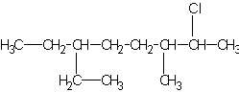
a. | 2-chloro-6-ethyl-3-methyloctane | d. | 2-chloro-6-propyl-3-methyloctane
b. | 2-chloro-6-ethyl-3-methyldecane | e. | 2-chloro-6-ethyl-3-methylheptane
c. | 2-chloro-6-methyl-3-ethyloctane

____ 61. Which one of the following compounds is not expected to be completely soluble in water at room temperature?
a. | CH₃CH₂CH₂OH | c. | CH₃(CH₂)₁₆CO₂H
b. | CH₃CO₂H | d. | CH₃OH

____ 62. Esters are
a. | found in some medicines | d. | found in some types of flavorings
b. | often fragrant | e. | all of the above
c. | essential oils in fruits and flower

____ 63. What is the proper name for the structure given below?
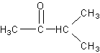
a. | 3-methyl-2-butanone | c. | 1-ethyl-1-propanone
b. | 3-pentanone | d. | 1,1-dimethyl-1-propanone

____ 64. The synthesis sequence shown here is best described as which of the following?

1. | 2. | 3.

a. | (1) Dehydration; (2) halogenation; (3) hydrogenation
b. | (1) Hydrogenation; (2) dehydration; (3) halogenation
c. | (1) Hydrogenation; (2) halogenation; (3) dehydration
d. | (1) Halogenation; (2) hydrogenation; (3) dehydration
e. | (1) Dehydration; (2) hydrogenation; (3) halogenation

____ 65. Select the compound with the highest boiling point at standard pressure.
a. |  | d.
b. |  | e. | 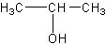
c.

____ 66. How many double bonds would be in one of the resonance structure of aromatic napthalene?
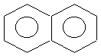
a. | 5 | c. | 4
b. | 6 | d. | 12

____ 67.
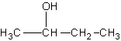
Which of the following is an oxidation product of the above compound?
a. | 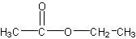 | c. | 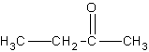
b. | 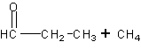 | d. | 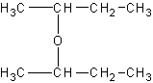

____ 68. What is the correct IUPAC name for compound below?
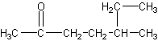
a. | 2-ethyl-5-hexanone | d. | 5-methyl-2-heptanone
b. | 5-ethyl-2-hexanone | e. | 2-heptanone
c. | 3-methyl-6-heptanone

____ 69. Which of the follwing compounds is 4-iodo-6-cyclopropyl-3-hexanone?
a. | 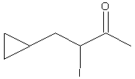 | c. | 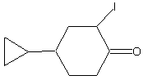
b. | 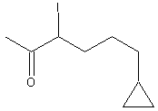 | d. | 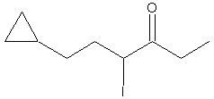

____ 70. In order to prepare the molecule shown below, which organic compounds must a chemist react under the appropriate catalyst/conditions?
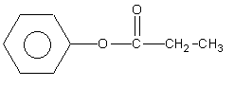
a. | 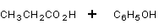
b. | 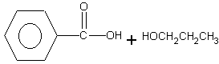
c. | 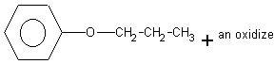
d. | 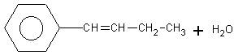

____ xx71. The product formed by the reaction of CH₃CO₂H with
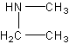
is properly named
a. | N-ethyl-N-methylethanamide | c. | N,N-diethylmethanamide
b. | N,N-diethylaminomethane | d. | N-ethyl-N-methylmethamide

____ 72. Which statement below is incorrect?
a. | the smallest aldehyde has the formula HCOH
b. | a carbonyl carbon consists of a carbon-oxygen double bond
c. | in an aldehyde, the carbonyl carbon is always bonded to a hydrogen atom
d. | Ketones are more soluble in water than alcohols with the equivalent number of carbons

____ 73. The correct name for the compound given below is which of the following?
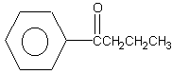
a. | 1-phenyl-1-butanone | c. | 4-phenyl-4-butanone
b. | phenylbutanal | d. | butanonebenzene

____ 74. Which compound is most likely to be a gas at room temperature?
a. | propane | c. | propanal
b. | 2-chloropropane | d. | propanone

____ 75. From the following list, select the two molecules that are isomers:
1. CH₃CH₂CH₂CH₂CH₃ | 2. CH₃CH₂CH₂CH(CH₃)₂
3. CH₃CH₂CH₂CH₃ | 4. CH₃CH₂CH₂-C(CH₃)₂

a. | (1) and (2) only | d. | (2) and (3) only
b. | (1) and (3) only | e. | (2) and (4) only
c. | (1) and (4) only

____ 76. Which of the following compounds is a secondary alcohol?
a. | 1-pentanol | c. | 2-pentanone
b. | 2-pentanol | d. | 2-methyl-2-butanol

____ 77. The compound shown below can be prepared by which of the following?
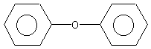
a. | substitution of benzene with chlorobenzene
b. | condensation of hydroxybenzene (phenol)
c. | hydrogenation of diphenylmethanone
d. | oxidation of diphenylmethane

____ 78. Carbon is able to form large numbers of organic compounds because carbon can
a. | form 4 bonds
b. | form single, double and triple bonds
c. | form chains, rings, spheres and sheets
d. | the carbon-carbon bond is very stable
e. | all of the above

Completion
Complete each sentence or statement.

79. The correct IUPAC name for the structure:

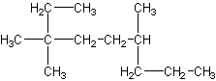 is ______________________________.

80. The correct IUPAC name for the compound:
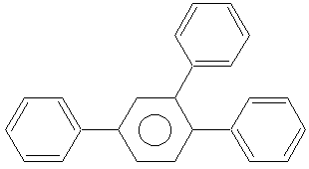 is ______________________________.

81. The structure of the compound produced by this reaction:
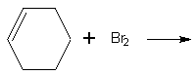 is ____________________.

82. The primary reaction product of the reaction given below is ____________________.
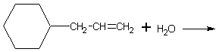

83. The correct IUPAC name for the structure given below is ______________________________.

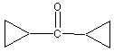

84. The correct IUPAC name for the compound formed by the reaction below is _________________________.

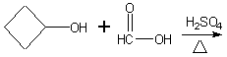

85. The correct IUPAC name for the structure given below is _____________________________________________.

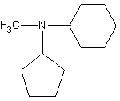

86. The number of moles of H₂ needed to completely saturate 1 mole of vitamin A is ____________________.

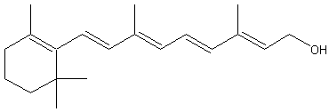

xx87. The melting and boiling points of organic compounds are dependent on the ______________________________ between the molecules.

xx88. The presence of OH and NH groups in an organic compound leads to _________________________ between molecules.

Matching

Match each of the following terms with its appropriate description.
a. | ethanol | h. | esterification
b. | elimination | i. | hydrogen
c. | methanol | j. | amines
d. | alkyl halide | k. | benzene
e. | primary | l. | carboxylic
f. | cyclic | m. | pheromones
g. | hydrocarbons

____ 89. this organic family consists of simple molecules of hydrogen and carbon that are the result of the breakdown of living organisms from long ago

____ 90. the name of the simplest aromatic organic compound

____ 91. an alkane that has one or more of its atom replaced by a halogen

____ 92. the most common type of reaction to produce an alkane

____ 93. an alcohol formed by yeast as a waste product while breaking down sugars

____ 94. to which menthol, cholesterol and phenol can all be classified

____ 95. the modern method to prepare this substance is to mix carbon monoxide with hydrogen at high temperature and pressure in the presence of a catalyst

____ 96. this group of complex ketones is used by insects as a sex attractors

____ 97. an aldehyde that reacts with hydrogen under high temperature and pressure in the presence of a catalyst always produces this type of alcohol

____ 98. these acids are generally weak and are found in citrus fruits, crab apples, rhubarb, and other foods

____ 99. the name of the reaction between a carboxylic acid and an alcohol in the presence of an acid catalyst and heat

____ 100. the smell of rotting fish is due to a mixture of substances with this functional group

____ 101. the high solubility of amines in water is due to this type of bond
Organic Chemistry
Answer Section

MODIFIED TRUE/FALSE

1. ANS: T REF: K/U OBJ: 1.7
LOC: OC1.01

2. ANS: F, methanoic acid REF: C OBJ: 1.7
LOC: OC2.04

3. ANS: T REF: K/U OBJ: 1.1
LOC: OC2.01

4. ANS: F, non-polar REF: K/U OBJ: 1.1
LOC: OC1.02

5. ANS: F, lower REF: K/U OBJ: 1.1
LOC: OC1.02

6. ANS: T REF: C OBJ: 1.2
LOC: OC2.02

7. ANS: T REF: C OBJ: 1.2
LOC: OC2.02

8. ANS: F, relatively unreactive REF: K/U OBJ: 1.3
LOC: OC1.03

9. ANS: F, 1,3 dichlorobutane REF: C OBJ: 1.4
LOC: OC2.02

10. ANS: F, lower boiling point REF: K/U OBJ: 1.4
LOC: OC1.02

11. ANS: T REF: MC OBJ: 1.5
LOC: OC3.02

12. ANS: F, lower REF: K/U OBJ: 1.6
LOC: OC1.02

13. ANS: T REF: K/U OBJ: 1.6
LOC: OC1.03

14. ANS: F, weak acids REF: K/U OBJ: 1.7
LOC: OC1.02

15. ANS: T REF: K/U OBJ: 1.7
LOC: OC1.02

16. ANS: F, lower REF: K/U OBJ: 1.8
LOC: OC1.02

17. ANS: T REF: K/U OBJ: 1.8
LOC: OC1.02

18. ANS: T REF: C OBJ: 1.9
LOC: OC1.03

MULTIPLE CHOICE

19. ANS: B REF: K/U OBJ: 1.8 LOC: OC1.01

20. ANS: D REF: K/U OBJ: 1.5 LOC: OC1.01

21. ANS: E REF: K/U OBJ: 1.5 LOC: OC1.03

22. ANS: E REF: K/U OBJ: 1.2 LOC: OC1.01

23. ANS: A REF: C OBJ: 1.2 LOC: OC2.02

24. ANS: D REF: C OBJ: 1.2 LOC: OC2.02

25. ANS: C REF: K/U OBJ: 1.6 LOC: OC1.01

26. ANS: C REF: K/U OBJ: 1.5 LOC: OC1.01

27. ANS: D REF: C OBJ: 1.5 LOC: OC2.02

28. ANS: A REF: K/U OBJ: 1.6 LOC: OC1.03

29. ANS: D REF: K/U OBJ: 1.5 LOC: OC1.02

30. ANS: C REF: K/U OBJ: 1.2 LOC: OC1.01

31. ANS: D REF: C OBJ: 1.2 LOC: OC2.02

32. ANS: C REF: C OBJ: 1.8 LOC: OC2.02

33. ANS: A REF: C OBJ: 1.2 LOC: OC2.02

34. ANS: C REF: C OBJ: 1.5 LOC: OC2.02

35. ANS: B REF: C OBJ: 1.2 LOC: OC2.02

36. ANS: D REF: C OBJ: 1.2 LOC: OC2.02

37. ANS: A REF: C OBJ: 1.2 LOC: OC2.02

38. ANS: D REF: C OBJ: 1.5 LOC: OC2.02

39. ANS: B REF: C OBJ: 1.8 LOC: OC2.02

40. ANS: D REF: C OBJ: 1.3 LOC: OC2.05

41. ANS: D REF: C OBJ: 1.2 LOC: OC2.01

42. ANS: D REF: C OBJ: 1.7 LOC: OC2.02

43. ANS: C REF: C OBJ: 1.2 LOC: OC2.02

44. ANS: B REF: C OBJ: 1.7 LOC: OC2.02

45. ANS: A REF: C OBJ: 1.2 LOC: OC2.02

46. ANS: A REF: C OBJ: 1.2 LOC: OC2.02

47. ANS: A REF: C OBJ: 1.5 LOC: OC2.02

48. ANS: C REF: C OBJ: 1.2 LOC: OC2.02

49. ANS: D REF: C OBJ: 1.6 LOC: OC2.02

50. ANS: D REF: C OBJ: 1.6 LOC: OC2.02

51. ANS: D REF: C OBJ: 1.2 LOC: OC2.02

52. ANS: B REF: C OBJ: 1.7 LOC: OC2.02

53. ANS: A REF: C OBJ: 1.7 LOC: OC2.02

54. ANS: B REF: K/U OBJ: 1.1 LOC: OC1.01

55. ANS: B REF: C OBJ: 1.3 LOC: OC2.05

56. ANS: D REF: C OBJ: 1.3 LOC: OC2.05

57. ANS: C REF: C OBJ: 1.3 LOC: OC2.05

58. ANS: A REF: C OBJ: 1.4 LOC: OC2.02

59. ANS: D REF: K/U OBJ: 1.4 LOC: OC1.02

60. ANS: A REF: C OBJ: 1.4 LOC: OC2.02

61. ANS: C REF: K/U OBJ: 1.7 LOC: OC1.02

62. ANS: E REF: K/U OBJ: 1.7 LOC: OC1.02

63. ANS: A REF: C OBJ: 1.7 LOC: OC2.02

64. ANS: E REF: K/U OBJ: 1.9 LOC: OC1.03

65. ANS: D REF: K/U OBJ: 1.5 LOC: OC1.02

66. ANS: A REF: K/U OBJ: 1.1 LOC: OC1.01

67. ANS: C REF: C OBJ: 1.6 LOC: OC2.05

68. ANS: D REF: C OBJ: 1.6 LOC: OC2.02

69. ANS: D REF: C OBJ: 1.6 LOC: OC2.02

70. ANS: A REF: C OBJ: 1.7 LOC: OC2.05

71. ANS: A REF: C OBJ: 1.8 LOC: OC2.05

72. ANS: D REF: K/U OBJ: 1.6 LOC: OC1.01

73. ANS: A REF: C OBJ: 1.6 LOC: OC2.02

74. ANS: A REF: K/U OBJ: 1.1 LOC: OC1.02

75. ANS: E REF: K/U OBJ: 1.2 LOC: OC1.01

76. ANS: B REF: K/U OBJ: 1.5 LOC: OC1.01

77. ANS: B REF: C OBJ: 1.5 LOC: OC2.05

78. ANS: E REF: K/U OBJ: 1.1 LOC: OC1.01

COMPLETION

79. ANS: 3,3,6-trimethylnonane REF: C OBJ: 1.2
LOC: OC2.02

80. ANS: 1,2,5-triphenylbenzene REF: C OBJ: 1.2
LOC: OC2.02

81. ANS: 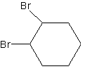 REF: C OBJ: 1.3
LOC: OC2.05

82. ANS: 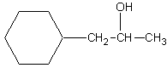

REF: C OBJ: 1.3 LOC: OC2.05

83. ANS: dicyclopropylmethanone REF: C OBJ: 1.6
LOC: OC2.02

84. ANS: cyclobutylmethanoate REF: C OBJ: 1.7
LOC: OC2.05

85. ANS: N-cyclopentyl-N-methyl-1-aminocyclohexane

REF: C OBJ: 1.8 LOC: OC2.02

86. ANS: 5.0 moles REF: C OBJ: 1.3
LOC: OC2.06

87. ANS: intermolecular forces REF: K/U OBJ: 1.1
LOC: OC1.02

88. ANS: hydrogen bonding REF: K/U OBJ: 1.1
LOC: OC1.02

MATCHING

89. ANS: G REF: K/U OBJ: 1.2 LOC: OC1.01

90. ANS: K REF: C OBJ: 1.2 LOC: OC2.02

91. ANS: D REF: K/U OBJ: 1.3 LOC: OC1.01

92. ANS: B REF: K/U OBJ: 1.4 LOC: OC1.03

93. ANS: A REF: K/U OBJ: 1.5 LOC: OC1.05

94. ANS: F REF: C OBJ: 1.5 LOC: OC2.04

95. ANS: C REF: C OBJ: 1.5 LOC: OC2.05

96. ANS: M REF: K/U OBJ: 1.6 LOC: OC1.05

97. ANS: E REF: K/U OBJ: 1.6 LOC: OC1.03

98. ANS: L REF: MC OBJ: 1.7 LOC: OC3.02

99. ANS: H REF: K/U OBJ: 1.7 LOC: OC1.03

100. ANS: J REF: MC OBJ: 1.8 LOC: OC3.02

101. ANS: I REF: K/U OBJ: 1.8 LOC: OC1.02

