This is Electrochemistry

This is what spontaneously happens when one immerses a copper metal mesh into a solution of silver nitrate. This is electrochemistry!

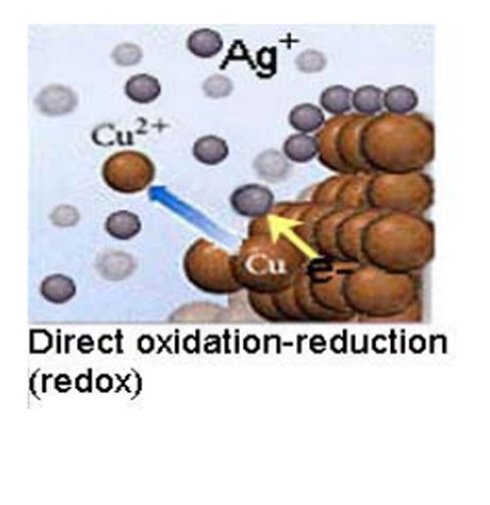
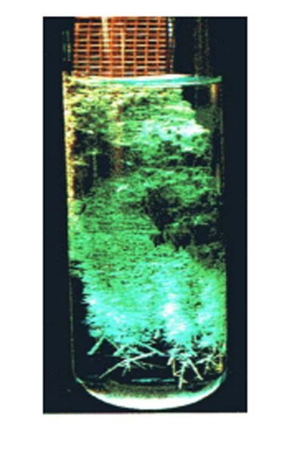
And is what spontaneously happens when one immerses a piece of zinc metal into a solution of copper nitrate. This too is electrochemistry.

